**Project Title: predicting the energy output of wind turbine based on weather conditions.**

**Team ID: PNT2022TMID13687**

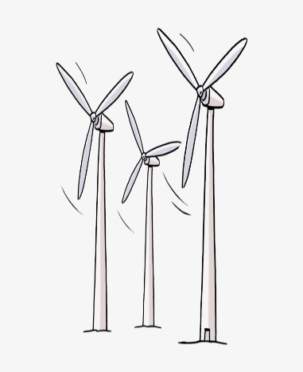 ↓↓

 predicting data

end

Output data

Data normalization

Extracting feature parameters

Training data set

Setting network simulation parameters

Data preprocessing

Input data